BEST PRACTICE – UPDATED 2023

TABLE OF CONTENT

A | Additional Vulnerability
B | Best Practice  Bullying and Banter
C | Changing Rooms  Communication
D | Data Storage & Retention
M | Mental Wellbeing
P | Parent Engagement & Communication  Photography  Position of Trust
S | Supervision & Ratios
T | Tours & Overnight Stays  Transport
V | Video Conferencing & Livestreaming
W | WhatsApp
Y | Young People in Adult Lacrosse  Young People Motivation

Additional Vulnerability
Whilst the phrase additional vulnerability suggest that certain individuals could be at greater risk of abuse or harm, this should not be assumed.

It is essential to create a culture and environment within your club that allows all members to feel included and safe: an environment that allows your members to flourish.

Individuals may be at greater risk of additional vulnerability to harm and abuse for the following reasons:
- Increased likelihood of social isolation
- Few outside contacts than other young people
- Dependency on others for practical assistance in daily living
- Impaired capacity to resist, avoid or understand abuse.
- Speech and language to tell others what is happening.
- Limited access for someone to discuss to
- Vulnerability to bullying.

Be aware, adaptable, promote inclusion and support individuals to be individuals. Sport is a wonderful place for people to express themselves as they may not feel comfortable to do so in other environments.

Groups considered to be at risk of additional vulnerability (but not exclusively)
- Deaf and disabled participants
- Lesbian, Gay, Bisexual, Transgender/Transsexual plus (LGBT+)
- Religion and minorities (including ethnic)
- Young officials
- Talented young athletes U18
- Talented athletes 18-25

Deaf and disabled people
Sullivan and Knutson (2000) found that children who are deaf or disabled are up to four times more likely to be exposed to abuse of harm that able bodied children (Sport disability & vulnerability – CPSU factsheet)

It is not only children with visible or physical disabilities who are at a greater risk of abuse, children with the following types of impairment are also at greater risk of abuse or harm.
- Hidden disabilities - such as learning disabilities, attention disorders, diabetes, dyslexia, epilepsy etc.
- Sensory – such as visual or hearing impairments
- Intellectual impairments – including young people with Down’s Syndrome
- Interaction and communication difficulties – Autistic Spectrum Disorder (ASD) including Asperger’s Syndrome

Find more information on Safeguarding Deaf and Disabled Children on the CPSU website

LGBT+
Many young lesbian, gay, bisexual, or transgender (LGBT+) people have difficult experiences when they reveal their sexual orientation or gender identity (CPSU 2016). It is important that sport is an inclusive and welcoming place for all young people as it may be the only environment in which they feel comfortable to be themselves.

To create a safe and inclusive environment in your club you should:
- Ensure everyone is treated with respect and individuals have equal opportunities to succeed.
- Tackle homophobia and transphobia in the same was as sexism, racism, or other forms of discrimination.
- Challenge gender stereotypes and celebrate individual differences.
- Promote inclusion.
- Encourage all young people to be themselves and support them.

This list is not exhaustive – Further resource to support young LGBT+ people can be found at:
- PrideSports
- CPSU
- Gendered Intelligence
- Stonewall
- Young Stonewall

Religion and minorities (including ethnic)
To increase participation of young people from minority groups, clubs should promote inclusion of all young people within sport. As a club you may need to consider the following when supporting your people:
- Culture – including dress.
- Festivals – Fasting during Ramadan
- Food & Drink – you may need to consider this for teas and social events.
- English as a second language or parents not speaking English – consider how to communicate effectively.
- Role models – whether within sport or outside, young people are often influenced by their role models.

Sporting Equals

Grooming, Extremism & Radicalisation
Young people who are vulnerable may be at greater risk of being groomed or exploited for reasons such as social isolation, low self-esteem, feelings of rejection or discrimination and strong feelings of anger or grief. The process of radicalisation may involve grooming (online or in person), exploitation (including sexual exploitation), psychological manipulation, exposure to violent material and other inappropriate information or risk of physical harm or death through extremist acts. (NSPCC)

If you are concerned that a young person is being groomed or radicalised and at risk of immediate harm, you must call the police. If it an emergency (young person is not in immediate harm or danger) consult your welfare officer or England Lacrosse’s Lead Safeguarding Consultant in the first instance.

- NSPCC – Radicalisation
- NSPCC – Grooming
- Gov.UK Prevent Duty Guide

Young Umpires
It is sometime the case that young officials will oversee games, involving adult players. Managing the behaviours, experiences and expectations of adults can be challenging for young, developing officials. There I heightened risk of experiencing verbal abuse if a decision made by the umpire/referee is perceived to be wrong. It is important to ensure young officials are supported and they have an experienced mentor who can advise them both on and off the pitch.

Make teams aware if a young umpire/referee is officiating and remind them of the club’s expected behaviours towards young people.

Talented Young Athletes (Under 18)
Talented young athletes may be at risk of being vulnerable due to the increased pressure placed on them, whether that pressure is from parents/family, coaches, peers or even from themselves. It is important to support young people in their development and help them reach their potential.

Talented young athletes may be additionally vulnerable due to any of the reasons below:
- More intense, dependant relationship with coach
- Performance environment – pressure to perform.
- Higher stakes – for young person and family
- More away, overnight trips and travel abroad
- Less family and social/other support network
- Isolated
- Self-image
- Child performing in adult based environment.
- Over training – training level/commitments
- Significant risk of poor mental health/wellbeing (see EL’s mental wellbeing guidance)

This list is not exhaustive.

In 2017 Baroness Tami Grey-Thompson published the ‘Duty of Care in Sport’ report. This report was conducted as an independent review into the duty of care that sport has towards its participants and the measures sports organisations can take to fulfil this duty. The report can be found here

The CPSU have several resources available to support and safeguard talented and elite athletes, which can be found here
Talented Athletes 18-25
Although this guidance is aimed at the additional vulnerabilities faced by young people under the age of eighteen, it is essential to recognise that the transition to adulthood can be challenging for many young people aged between 18-25. Young people do not automatically become responsible adults overnight upon reaching their 18th birthday and may need continued support, especially if they are in a talent environment as many of the factors that related to under eighteen’s will remain:
- A win at all costs approach
- Intense coach – athlete relationships
- Being away from family and support networks
- Fear of losing a place on the programme if they speak out.

In a talent environment, there will still be high dependency on coaches and support networks therefore it is important to ensure that they have someone they can speal to who can help them through this transition.

CPSU – Elite Athlete Welfare

Further Considerations
There are certain considerations that must be made to make sure young people are supported in their development such as:
- Facilities – are the facilities suitable for young people with additional needs.
- Accessibility (not just disabled access) – are your sessions young people friendly.
- Privacy – changing facilities can often be a big issue for the groups identified in this document.
- Support – do you have the necessary support in place for individuals who may be a greater risk of harm or abuse?
- Increased supervision ratios – do you need to increase supervision ratios to better support your training sessions/matches.
- Relevant training – do your coaches/volunteers require specific training to better support them in their role.
- Awareness of the importance of mental health – be aware of the links between physical and mental health, how to promote positive mental health and what to do if you are concerned about a young athlete mental health.

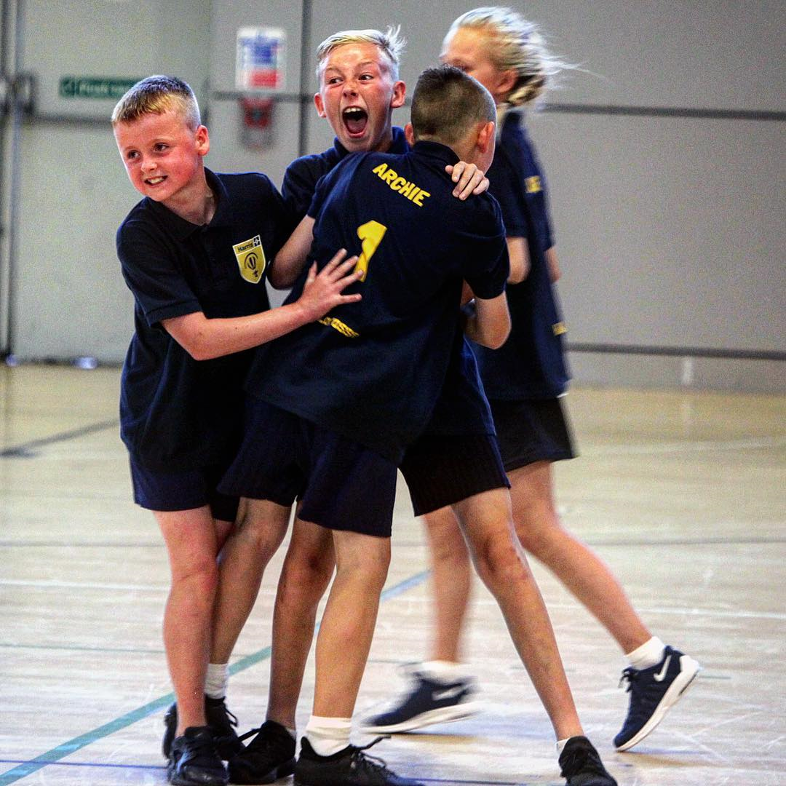
Best Practice
Lacrosse has young people playing regularly in teams with adults, there are very few situations where no young people are present.

Therefore, it is important to remember that safeguarding is everyone’s responsibility.
- The welfare of the child is paramount.
- All children, regardless of sex, gender, age, race, marital status, pregnancy, sexual orientations, religion, ability, or disability, have the right to enjoy lacrosse in an environment that is safe from any kind of abuse.
- Safeguarding is not solely about preventing abuse, but also providing the best environment possible to all young people to enjoy the sport.
- Create an environment where sport is fun and enjoyable for all and enjoyable for all and encourage fair play.
- Strive to be a good role model to all young people.
- Encourage involvement of parents/carers backed up by good and consistent communication.
- Include young people in decision making processes – especially if that decision has the potential to impact young people’s future involvement in the sport.
- Set guidelines on what behaviour/language is and is not acceptable – create a culture where inappropriate language/behaviour can be challenged.
- Take all allegations, concerns, and suspicions of harm seriously and respond to them in a way that is fair, swift, and appropriate.
- Work in an open environment wherever possible; avoid situations where you could be alone with a young person.
- Avoid placing excessive amounts of pressure on young people – whilst they may play in a competitive setting there should be a greater emphasis on their development and having fun playing lacrosse.
- All clubs/associations with young people must appoint a club Welfare Officer (WO) to ensure compliance with England Lacrosse’s policy, procedures, and best practice guidance.
- All concerns should be reported to the WO in the first instance. If the concern involves the WO, you should contact England Lacrosse Lead Safeguarding Consultant. If a child is in immediate danger, contact the police.
- Remember – it is not your responsibility to decide if a situation is poor practice, abuse or bullying, but it is your responsibility to report your concerns.

Avoid
- Spending excessive amounts of time alone with young people, away from others
- Taking young people alone on car journeys, no matter how short the distance
- Taking young people to your home, or any place they will be alone with you.
- Putting yourself in any situation with a young person that you/they are comfortable with

Never
- Engage in personal relationships (including sexual relations) with any young person.
- Engage in rough, physical, or sexually provocative games.
- Allow or engage in any inappropriate physical, verbal, or online communication (social media/messaging) with young people.
- Allow young people to use inappropriate language unchallenged.
- Make sexually suggestive comments to a young person, even in fun.
- Allow allegations of a young person to go unchallenged, unrecorded, or not acted upon
- Do things of a personal nature for young people that they can do for themselves.
- Invite or allow young people to stay with you at your home unsupervised
- Allow any form of bullying or bad behaviour by young people.
- Allow yourself to be drawn into inappropriate attention-seeking behaviour or make suggestive or derogatory remarks or gestures in front of young people.
- Jump to conclusions about others without checking facts.
- Either exaggerate or trivialise child abuse issues
- Show favouritism to any individual.
Key Top Tips
In the case of an emergency where these situations may be unavoidable, they should only occur with full knowledge and consent of the young person’s parents/carers. These situations should always be reported to your Club Welfare Officer.
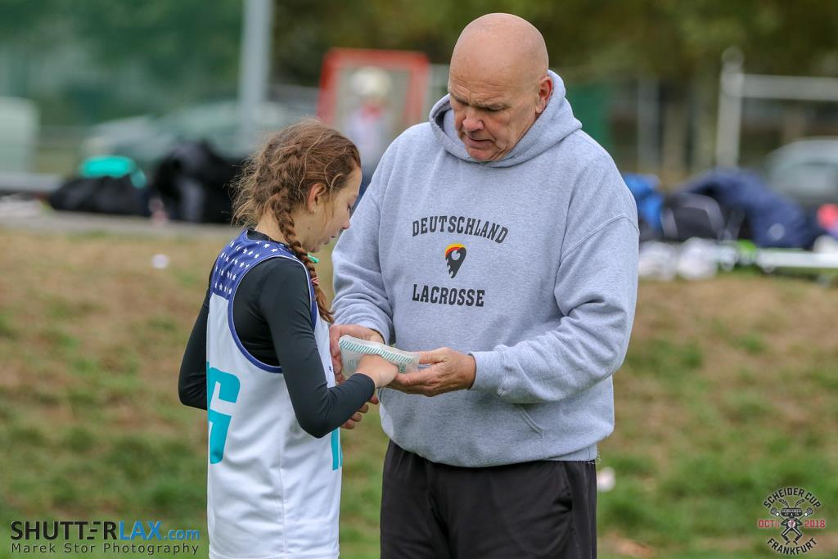

If you accidentally hurt a young person, the young person seems distressed in any manner, appears to be sexually aroused by your actions, or misunderstands or misinterprets something you have done, report any such incident as soon as possible to another colleague and make a brief note of it. Parents or guardians should be informed of the incident.
It is strongly recommended that you do not work completely alone with groups of young people. Enlist the support of the others – assistants, parents/carers etc.
Make sure you provide support and guidance to all individuals representing your club on the appropriate ways to interact and engage with young people in lacrosse.

Bullying & ‘Banter’
Everyone as the right to be treated with respect. England Lacrosse is committed to creating and maintaing an environment in which all young people involved in lacrosse are free from bullying

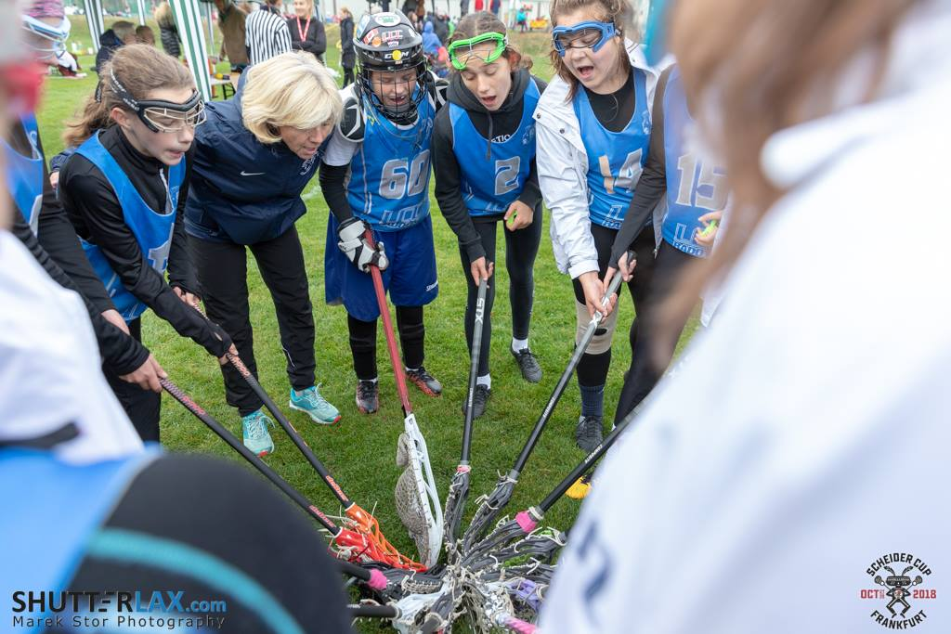

Bullying is usually defined as behaviour that is repeated, used with intent to hurt someone physically or emotionally and often aimed at certain groups such as race, religion, sex and gender or sexual orientation. Bullying can take place between young people.

Bullying can take many forms including:

- EMOTIONAL - Persistently being unfriendly, excluding, tormenting, threatening gestures.
- PHYSICAL - Pushing, kicking, hitting, punching or any other violence.
- RACIAL, SEXIST OR HOMOPHOBIC - Racist remarks, sexist jokes, or comments, or homophobic, transphobic, or gender-related jokes or comments
- SEXUAL – Abusive sexualised name-calling, inappropriate and uninvited touching, or an inappropriate sexual proposition
- VERBAL ABUSE – Offensive name-calling, sarcasm, spreading rumours, teasing.
- NON-VERBAL ABUSE – Offensive hand signs or text messages
- INDIRECT – Spreading nasty stories or rumours about someone, intimidation exclusion from social groups, manipulating or constantly undermining someone.

CYBERBULLYING
Any form of bullying that is carried out through the use of electronic media devices, such as computers, laptops, tablets, smartphones or gaming consoles (Anti-Bullying Alliance). Cyber bullying can occur between an adult and a young person or can be per on peer between young people.

Bullying has become far wider spread due to online platforms. The nature of online activity means it is possible for the instigator to hide their identity, to harass the victim at any time and to reach a wider audience.

Sexting is another form of cyberbullying. This is when someone shares sexual, naked, or semi-naked images/videos of themselves and/or others or sends sexually explicit messages on any device that allows the sharing of media and messages.
(NSPCC)

There is no single sign that a young person is being bullied, however if you notice changes in behaviour such as nervousness or loss of confidence, physical injuries such as unexplained bruises, notice that their belongings are getting lost or damaged, becoming afraid to attend school/training or making excuses to avoid attending these signs could indicate that the child is being bullied.

Banter
“The playful and friendly exchange of teasing remarks” – Oxford Dictionary

Whilst banter is commonly used in sport at all levels, it is imperative to understand when the line has been crossed. Excessive and repetitive teasing is a form of bullying.

Banter involves people with equal power, where there is no intent to cause harm and no hurt involved. Banter becomes bullying when it is consistent, hurtful or when there is an imbalance of power, for example a coach and player, teacher, and pupil or even peer to peer.

Just because you think something is banter or a joke does not mean other people will.

People will not always feel confident to speak up if they are offended by something. They might even go along with it so as not to draw attention to themselves.

Banter should never be used as an excuse to bully another person and should be challenged.

More information and resources on banter here

on

What to do
Do not make assumptions that young people cannot deal with it, but equally do not ignore the problem. Ask the induvial what they want you to do to take the matter forward rather than taking over so they do not feel excluded or more stressed/worried than they already are.

You will need to make a judgement call if a young person does not want you to do anything – is that young person at danger of further hurt and upset if you do not step in?

Reassure and encourage the young person and work with them to find an outcome – they may simply want to talk to someone about their situation, or they may want your help.

Dealing with bullying behaviour (this may differ dependent of age) – talk to the individual displaying bullying behaviour and explain the situation, trying to get them to develop an understanding of the consequences of their behaviour. This may be achieved by:
- Developing, maintaining, and repairing positive relationships
- Helping young people learn and develop the skills to make good choices.
- Enabling young people to recognise when they have harmed another person and how to put it right.
- Encouraging young people to consider the impact their behaviour has on others.
- Parent involvement
Other considerations:
- Try to seek an apology from the person displaying bullying behaviour to the recipient.
- Inform the parents of the person(s) displaying bullying behaviour so that they might talk to their child about the behaviour too.
- Impose sanctions that are relevant and proportionate, as necessary.
- Hold meetings with the families to report on progress.
- Keep written record of action taken.
- Review any learning from having to respond to bullying behaviour.
CPSU, Anti-Bullying
Who to contact?
- England Lacrosse Led Safeguarding Consultant – offer support and advice on any aspect of bullying safeguarding@englandlacrosse.co.uk +447546614756/+447729720149.
- Anti-Bullying Alliance
- Childline 08001111
- NSPCC 0808 800 5000
- CPSU

CHANGING ROOMS
Changing rooms play an integral part of the environment in lacrosse, not only for tier intended use but they also provide a place pre-match discussion, debrief or to celebrate wins.

Whilst changing rooms appear to be the idea place for this use, they can also be intimidating places for young people, especially those playing in senior teams.

The following are examples of good practice guidelines when using changing rooms:

- Players aged ten and under must be supervised always in changing rooms by two members of staff of the same gender as the players, who hold the appropriate checks
- When young people are playing for adult teams, it may be the case that they will use the changing rooms at the same time. In this event, young people should have access to separate showers/changing space within that room for privacy. Young people and their parents must be informed of the club’s policy on changing arrangements.
- Young people can become intimidated or uncomfortable in certain situations and are often self-conscious and anxious about changing in front of others. If young people are uncomfortable changing or showering in public, no pressure should be placed on them to do so. Encourage them to do this at home.
- If you are using a changing room for debriefs following a game, make sure that all parties have been informed and are suitably dressed.
- If you have young leaders (under 18) involved in running sessions for other young people, it is not appropriate for them to change together as they are in a position of trust, make alternative arrangements for them to change (i.e., before/after other young people or change at home).
- Adults working with young teams, including volunteers, coaches, umpires, or staff, must not change or shower at the same time when using the same facility as young players.
- If your club has disabled players, involve them and their parents/carers in deciding how, if applicable, they wish to be assisted to change and ensure they provide full consent to any support or assistance required.
- There is the potential that mobile phones may be used inappropriately in changing rooms, resulting in inappropriate photography or filming, therefore clubs are advised to consider banning the use or misuse of mobile phones in changing rooms. Posters such as ‘the no camera zone’ can be used to increase visibility of the club/association’s stance towards the use of mobile phones in changing rooms.
- Always use appropriate language and behaviour around young people. Do not use ‘banter’ as an excuse. See England Lacrosse guidance on bullying and banter above.
- If no changing facilities are available, all players should be informed in advance and advised to make alternative arrangements/bring appropriate additional clothes.
- It is the responsibility of all members to report unacceptable behaviour and to challenge any action which contravenes the Code of Conduct (Respect)

Transgender and Transitioning Young People
There are a number of considerations relating to changing rooms to be made when addressing the needs of young transgender or transitioning people including:
- The young person’s feelings and preference about which gendered changing room they would like to use.
- The privacy of the young person
- The feelings and privacy of other young people in the sae changing room.
- Practical arrangements such as leaving young people unsupervised, the risks of bullying or unwanted/inappropriate behaviour towards the individual.
- If a young person self-identifies as a gender that differs to the gender they were assigned at birth, they may wish to start changing with other young people of the same gender identified or ask for privacy. Consider what reasonable adjustments to changing arrangement can be made to accommodate the needs of all young people to help reduce the risk of bullying behaviour or distress. You may wish to provide private, separate changing spaces for the individual(s)

Further information can be found here

Communication

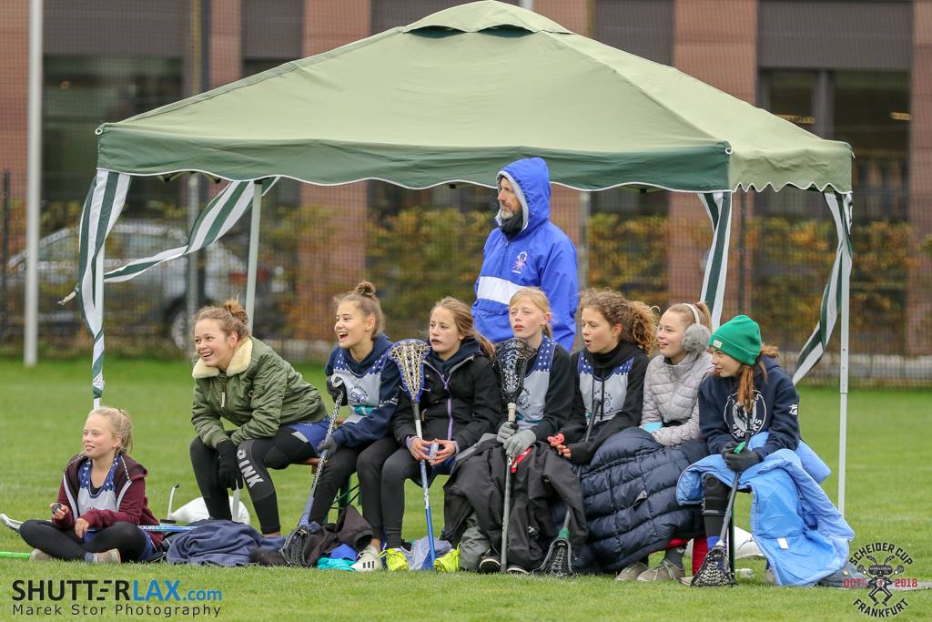

Positive communication is essential in sport; whether the method of communication used for messages detailing training, selection of match day squads or the celebration of members and their successes, clear and effective communication is key for all involved in lacrosse – including young people.
Communicating when you are in a Position of Trust
In line with England Lacrosse’s ‘Position of Trust’ guidance, certain considerations must be made when individuals who are in a position of trust communicate with young people. Individuals in a position of trust for young people I lacrosse have a duty of care to protect the welfare of these young people.
This is not excusive to coaches, Positions of trust in lacrosse will include young leaders, coaches at all levels captains, team managers, medical professionals, officials, coaches, and mentors. This list is not exhaustive.
Basic do’s and don’ts when communicating with young people.
DO
- Promote positive communication.
- Contact players only when necessary.
- Make sure the method of communication is right for your environment.
- Copy parents/guardians into any communication with young people
- Check that young people are receiving essential information if your route of communication is through parent/guardian.
- Agree good practice on how to communicate with young people in our club (e.g., club policy on communication)
- Make sure the mechanism for two-way communication, allowing young people to express their views.
- Use social media channels in a positive way to promote and celebrate the successes of your clubs.

DON’T
- Contacting a young person unnecessarily
- Rely on apps/text/email to get your messages to young people.
- Communicate directly with U18s without gaining consent from parent/guardian.
- Give the wrong impression to a young person.
- Communicate with young people on matters not related to lacrosse.
- Accept ‘friend requests’ from young people if you are in a position of trust over them.
- Compromise the safety of young people by making or receiving phone calls when you full attention should be directed to the individual(s) (e.g., when coaching)
Personal vs ‘professional’ profiles
It is advised that you keep your private and professional accounts separate on social media. Ensure that professional accounts do not contain or promote inappropriate content. It is important to set and maintain boundaries with young people that you are coaching as you are in a Position of Trust.
Things to be aware of
It is important to acknowledge technology and the speed at which it moves – many young people may not use or have access to an email account, or age limits for apps such as WhatsApp may restrict the ways in which you can contact young people – ensure you find a method that works for your club and you agree it with parents/guardians.
Bullying does not only occur verbally, but cyber-bullying can also occur online from devises such as phones or tablets. Bullying generally occurs between peers. For more information on bullying see EL’s Anti-Bullying Guidance.
Technology - There are several apps that can be used as communication tools. Some of these, such as WhatsApp, have legal restrictions and minimum age limits. Therefore, it is essential to check the method of communication before using it with young people.
Systems - Club membership systems such as Pitchero, ClubBuzz etc. are widely used in lacrosse. They provide tools for easy administration, communication, websites etc. When using systems such as these in clubs, make sure you inform parents and young people what you intend to use the information for and how it will be stored (see Data Storage & Retention). If you are using these systems for the purpose of communication, ensure you follow the guidance outlined in this document.
1-on-1 communication – there may be times when you need to communicate with an individual away from their peers or team-mates. In this situation, make sure they are supported by another individual such as a peer, parent or guarding and you have another adult present. If you need to communicate with a young person individually via text, email etc. make sure a parent/guardian is included in the conversation.
Grooming – 1-on-1 communication can be used to groom young people for sexual abuse or radicalisation. If you are concerned that a young person is being groomed or radicalised and is at risk of immediate harm you must call the police. If it is not an emergency, consult your welfare officer or England Lacrosse Safeguarding Lead Consultant.
Social Network – Social media sites such as Facebook, Twitter, Instagram, Snapchat etc. are widely used by young people. It is essential that individuals such as coaches who are in a position of trust are advised to set their privacy settings so that young people cannot access their information.
Livestreaming and video conferencing – The use of platforms such as Zoom, SKYPE, Teams etc. for coaching or communicative purposes has rapidly increased over time. Guidance on the use of video conferencing or livestreaming is available later in this document.
Giving young people a voice
In addition to considering how to communicate with young people in your club/association, it is also important to consider how to ensure that young people can express their thoughts and opinions. You may wish to run forums on a regular basis to allow young people to share their views, you might consider having your representatives on your committee – whatever route you choose to follow, it is important to make sure young people feel confident to express concerns, share their thoughts and aid development of the club, themselves and their peers.
Access FREE online webinar training here
Best Practice Advice from CPSU
Parent/Guardian expectations and engagement
Parents and guardians play a huge role in the development of young people. They are often the people responsible for driving players and training and matches and can invest substantial amounts of time effort and finance resource into ensuring they support their child/children in the sport.
It is important to ensure that clubs/associations work with parents and/or guardians, outlining expected behaviours of both parents and/or guardians and the club/association. Club/Associations should not assume the knowledge level or commitment to the sport of parents and/or guardians. Outlining expected behaviours and values at the start of each season and offering regular meetings to parents can go a long way in supporting parents and/or guardians within lacrosse. Not all parents and/or guardians will engage with the sport their child/children have choose, therefore it is essential to consider how you will communicate with young people and their parents and/or guardians to make sure important messages get through to young people.
Positive parental engagement is important, parents can be a brilliant resource to their own child(ren) and potentially to the club or organisation as they may bring skills, knowledge, and expertise.
Poor parental behaviour also has an impact on young people, the ‘Magic Sports Kit’ is a very powerful video that highlights the impact from a child’s perspective.
Other resources:
CPSU – Parents
EL Code of Conduct for Spectators and Parents (Respect)

DATA STORAGE AND RETENTION
What do you need to know about young people in your club/association to fulfil your duty of care?

Certain data and consent must be gained when you have young people in your club/association. When gaining consent from parent/guardian, you must inform them of the following:
- The reason for collecting data.
- How you will store it
- How it will be shared (e.g., with the young person’s coach)
- All personal information should be processed, stored, and retained in accordance with the General Protection and Data Regulation (GDPR) requirements.
You will need to collect the following:
- Consent for photographic and recorded images
- Medical information & consent to administer medication i.e., EpiPens (including emergency medical attention)
- Next of kin and emergency contact details
This information could be collected by use of a membership form and collated in a centralised database. Ensure that any data collected is protected, for example by use of a password. Club systems, such as Pitchero or ClubBuzz may have tools in place to assist clubs with storing and managing data in a way that is compliant with GDPR.
Clubs should have a storage and retention policy relating to the information they hold regarding their members. The information Commissioner’s Office (ICO) guidance regarding data storage and retention can be found here. How long you hold data will depend on what it is and whether there are any statutory requirements for data to be held for certain periods of time. For an example of this, see England Lacrosse’s Privacy Notice and associated policies, found here or by searching ‘Privacy Policy’ on England Lacrosse’s website.
Your data storage and retention policy should also outline how you will erase data once it is no longer required. You can find guidance on deleting personal data from the ICO here

How should I share this data and with whom?
Sensitive data is any information that can be used to identify an individual, or contains information regarding an individual e.g., allergies, medication etc. Once you have consent for sensitive information to be collected, you need to consider who will require access to this and how it can be accessed. If data, such as medical information or consents, for you members (including young people) is stored on a centralised database, you will need to make sure this information is accessible in an emergency to fulfil your duty of care.
You will need to make sure that any relevant adults e.g. the coach, the team captain (if over 18) or nominated responsible adult is aware of any medical conditions that may affect a young person whilst in their care (such as asthma, EpiPens etc.) as they have a legitimate interest to hold this data to fulfil their duty of care. You will need to make sure this information is updated as required.
Whilst most clubs may use an electronic system t collate medical information, emergency contact details and consents, if this is not accessible pitch side you may need to consider a ‘back up’ for sharing this data – you could have a printed copy in a sealed envelope in case of emergency.
If you use back up paper copies of medical information, emergency contacts and consents, consider how the individual this is shared with stores this data – giving guidance such as not leaving these documents in an open kit bag that may be easily accessible to other people.
These data storage principles also apply to storing photographic or recorded images, including, but not limited to:
- Gaining consent to record, store, and use images
- Informing individuals on where these images are stored.
- Consideration to who as access to these images
- Password protection if images are stored on a shared area.
- Having a storage and retention policy (including deletion of images)

MENTAL WELLBEING
“Mental Wellbeing describes your mental state – how you are feeling and how well you can cope with day-to-day life. Our mental wellbeing is dynamic it can change from moment to moment, day to day, month to month or year on year.”
(Mind 2019)
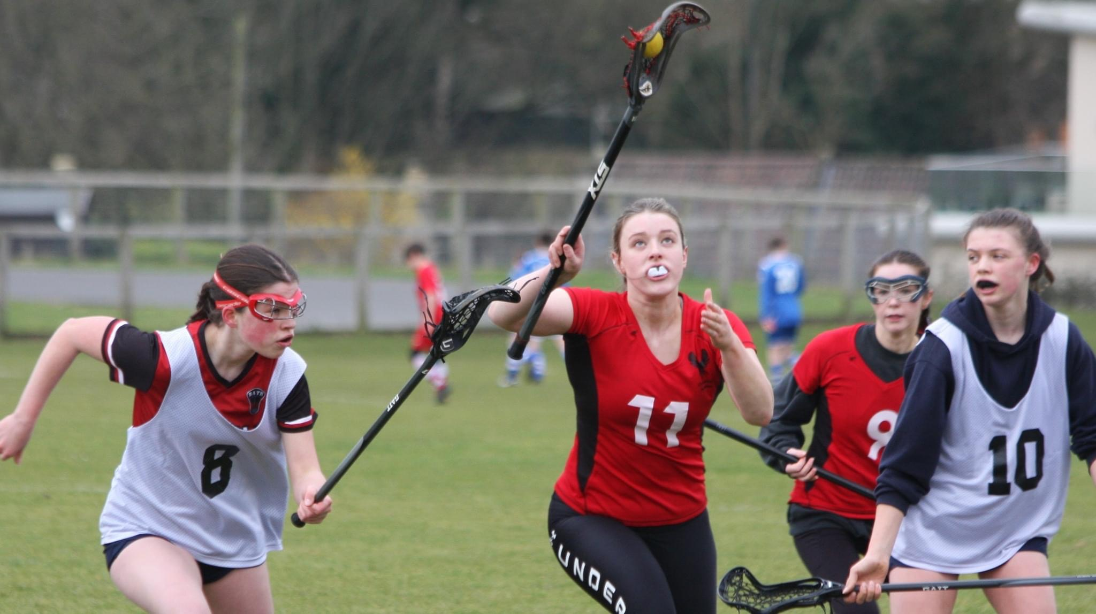
Everyone will be exposed to situations which may affect their mental wellbeing, both in a positive or negative way. Every individual will be affected in a separate way; it is normal to have times of low mental wellbeing where we feel stressed, upset, or overwhelmed.
Physical activity has many positive benefits for mental wellbeing and should be widely encouraged. Not only does sport offer a relief from other issues a person may be dealing with, but it offers social interaction with team sport such as lacrosse providing an extensive support network for individuals.
What factors can affect a young person’s mental wellbeing?
There are many varied factors that affect a young person’s mental wellbeing for example:
- Social pressures
- Family pressures
- Relationships
- School pressures e.g., exams
- Pressure to perform.
- Social media
- Additional vulnerabilities e.g., LGBT+, talented athletes, ethnic groups etc. (England Lacrosse’s Additional Vulnerability Guidance is at the beginning of this document)
This list is not exhaustive.
For some young people, these factors may not affect their mental wellbeing, whereas others may be affected and will subsequently suffer with poor mental wellbeing. It is important to support all young people and create an environment where they feel they can speak to someone if they are struggling with mental health issues.

What signs should clubs look for?
Every individual is different. Individuals who are experiencing decreased mental wellbeing may display some of the following:
- Dramatic changes in an individual's language or behaviour
- Social withdrawal
- Rapid mood changes
- Dramatic changes in routine (e.g., sleeping habits and eating)
- Difficulty concentrating
- Unexplained weight loss or gain
- Physical harm or substance abuse
If you are concerned about a young person, speak with your welfare officer in the first instance.
If you are concerned that the young person is in immediate danger of harming themselves or others, you should call 999.
How can clubs support young people?
It is important to promote positive wellbeing and create a nurturing environment where young people feel they can raise concerns and feel supported to speak to someone when they are struggling – whether this is another member of the team, a coach, the welfare officer, or anyone else they feel comfortable speaking to. Young people need to feel reassured that their concerns will be listened to and that someone can support them.
If someone discloses to you, take advice – you do not have to fix this! Your role is to support and advise services that can support young people. Schools will often have links with people who can offer a greater level of support to young people. You are advised to have awareness of mental health, to reassure the individual and seek advice on how you can support them.
More information is available here
What resources are available to help clubs support young people?
There are a number of organisations and charities set up to support young people who are experiencing decreased mental wellbeing, including those specific to self-harm and eating disorders.
NSPCC – Child Protection in Sport Unit (CPSU) Promoting positive mental wellbeing
- Mind
- Young Minds
- Believe Perform
- Childline
- Beat (eating disorders)
- Self-Harm UK
- Samaritans
- Prince’s Trust
- Papyrus
- The Mix
- Calm Harm

Training
UK Coaching have worked with 1st4Sport’s an mind to develop an online course ‘Mental Health Awareness for Sport and Physical Activity’
Reporting Concerns
If you are concerned about a young person’s mental wellbeing, report to your organisations Welfare Officer or take advice from England Lacrosse Safeguarding Lead Consultant.
Safeguarding@englandlacrosse.co.uk
+44 (0) 7546614756/ +44 (0) 7729720149

PARENT ENGAGEMENT AND COMMUNCATION
Parents and guardians play a huge role in supporting their children in all aspects of their sporting life and the importance of positive engagement should not be under-estimated.
Parents and guardians are often responsible for driving players to training and matches and can invest substantial amounts of time, effort, and financial resource in ensuring they support their child/children in the sport.
Positive engagement with parents and guardians is essential, effective communication will help parents/guardians understand what is expected of them and their child/children.
What should parents/guardians expect from clubs/organisations?
- Effective communication with parents/guardians – considers how you will communicate with parents/guardians – tell them what to expect i.e., frequency/mechanism/their role.
- Ensure safety of young people while in care of club
- Adopt EL’s Safeguarding policy and implement best practice.
- Ensure all concerns are taken seriously and dealt with in an appropriate manner in accordance with EL’s reporting procedures.
- Have a named Welfare Officer(s) and know how to contact them.
- Ensure coaches are appropriately skilled and have completed training relevant to their role, including safeguarding education (this should be renewed every 3 years)
- Ensure Disclosure and Barring Service (DBS) checks are completed where required.
- Arrangements for pick up and drop off, including ensuring young people are not left unattended, ensuring young people do not enter the pitch unsupervised and do not start using balls or sticks until supervised activity commences.
- Hold their child’s medical details and parents/guardian contact details and only share with those that ‘need to know’ them to fulfil their duty of care.
- Be made aware of any injuries and subsequent treatment, to their child as result of their lacrosse activity.
Club/Organisations should make parents/guardians aware of the specifics of how they operate, including the following:
Engagement
Clubs should be clear on how they will engage with parents – this could be through a beginning of season briefing or regular newsletters.
Be clear with parents how you will engage and who they should speak to about various aspects of their child’s lacrosse experience, how to contact them i.e., coach/junior organiser/ welfare officer.
Lacrosse Specifics – do not assume parents will understand lacrosse terminology or etiquette. Be clear on parent and child expectations on all aspects of club activity i.e., where to spectate from, drop off arrangements, times of matches, equipment, clothing, safety.
Safe Lacrosse – let parents/guardians now about:
- supervised ratios (found later in this document)
- first aid
- on and off pitch etiquette
- Concussion
- Injury prevention

Collection/drop off arrangements
It is important to consider how your club/organisation needs to adapt its practices in relation to the age of the young person. For example, drop off and pick-up arrangements may differ for a 10-year-old compared to a 16-year-old. Clubs/organisations should consider their venue an environment in relation to the guidelines provided for parents/guardians.
Communication
Parents/guardians should be copied into all communication to U18’s.
For transparency clubs should be clear on how they will/will not communicate with all young people i.e., use of WhatsApp groups (be aware of age limitations for various social media platforms). See EL Communications guidelines earlier in this document.
Social Events
When organising social events clubs/organisations should consider the environment that young people are involved in. Consider the nature of the event and the mix of adults/young people. Is the environment suitable?
Be clear on the position on alcohol (illegal to sell to under eighteen’s) and ensure young people and their parents understand it.
Clubs/organisations always have a duty of care to young players. This should be considered when planning and during an event.
Selection/Transition
Engagement with parents/guardians about the process for transition into adult lacrosse is essential. Transparency around understanding the rationale/process, who will make the decisions, what factors engage in making those decisions, is important to parents and their child. Every child is different so ‘a one size fits all’ approach might not be appropriate but needs explaining.
What should clubs expect from parents/guardians?
- Ensure young people are dropped off and picked up promptly from the venue and that young people are not left unsupervised at any time.
- Ensure there is an appropriate coach in attendance before dropping your child off before a session or match.
- Contact session organisers/coaches if running late to collect young people.
- Adhere to the Parents section of the Code of Conduct (Respect)
- Always use appropriate language
- Stay off the pitch during training and matches.
- Provide emergency contact details and any relevant information about young people including medical history. Update the club if this information changes.
- Speak to the Welfare Officer as soon as possible if you have any concern. The sooner the club are aware, the sooner it can be looked into/resolved.
- Support with transport arrangements
PHOTOGRAPHY/STREAMING/IMAGERY

Positive images of young people enjoying lacrosse are essential to promote the sport and a healthy lifestyle. Parents/carers want to celebrate the achievements of their children through photographs and recorded images. Use of recorded images can also be a valuable coaching aid. England Lacrosse is committed to providing a safe environment for all young people and it is therefore committee to ensuring that all necessary steps are taken to protect young people from the inappropriate or uninformed use of their images in resources and media publications, on the internet and elsewhere.
Photographic and recorded images can also be used to identify people if accompanied by personal information. Additionally, images can be used or adapted for inappropriate use. This includes any device that is equipped to capture and record images (e.g., digital camera, video recorder, mobile phone, tablets etc) both live and delayed.
A clear statement should be written, publicised, and promoted for all lacrosse activities, which includes “the interests and welfare of young people taking part in lacrosse is paramount.” The use of posters identifying ‘no camera zones’ in changing rooms and the promotion of positive imagery can help to protect young people but consider how visible and accessible this information is. If using hired facilities, it may not be possible to put up posters – consider how to communicate these messages to members.
Whilst use of want to promote positive and appropriate images, we must all be aware that some young people will be subject to legal proceedings and in some cases, restrictions will be in place to ensure the young person is protected. In this circumstance, gain consent and information from the parent/guardian and work with them to make sure appropriate measures are in place. Also agree who needs to know this information, so that you are compliant with the arrangements.
Protecting the Identity of Young People
It is essential to protect the identity of young people when using images on websites, social media, promotional material etc. Ensure that the persons details are not connected to an image - for example do not us a young person’s full name, age, and location in conjunction with their image.

TAKING AND/OR PUBLISHING OF PHOTOGRAPHIC AND RECRODED IMAGES OF YOUNG PEOPLE:
- Written consent to take and use images should be obtained from both the young person and parents/guardians must be gained. (See template for more information)
- Consent forms must clearly detail the intended collection and use of the photographic/recorded images (e.g., promotional use, coaching aids etc) and how collected images will be stored.
- Encourage the reporting of inappropriate use.
- Images should be focused on the activity rather than the young person.
- Communicate your policy on imagery to all parents/guardians so they know how any images taken will be used i.e., no identification, newsletters only or website.

Recorded Images
Recorded images are commonly used for coaching purposes or as evidence for exam boards during GCSE’s and A ‘Levels. When filming young people in lacrosse it is important that you make others aware of your intentions including the purpose of the filming, how the images will be used and stored and what will happen to the footage once its need is fulfilled. If you are filming a match, inform the opposition the reasons for filing and ask consent to film. Make other young people and their parents/guardians aware of the purpose and gain their consent to be filmed.
Live streaming is becoming an increasingly trendy way of sharing content. Live streaming involves broadcasting a live video to an audience over the internet using a device such as a mobile phone or tablet – this could be to a single person or a wider audience. Unlike recorded images, live videos are uncensored and cannot be edited. When used in a positive way, live streaming can be a great tool in sport. However, it can be unpredictable and hard to moderate. For further information visit www.thinkuknow.co.uk/parents

Club/Event Photographers/Videographers
The use of official club/event photographers/videographers is a terrific way of taking professional images reflecting the positive and inclusive nature of lacrosse. Club/event photographers do not fulfil the requirements of regulated activity in relation to DBS checks (see EL DBS guidance here). However, when photographers/videographers are used to capture images of young people, it is important to agree good practice between the club and photographers/videographers to ensure that all parties are protected.
When young people are being photographed, filmed consider the following:
- Make sure club/event photographers/videographers are easy to identify – photography/filming bibs are often the easiest way to make official photographers/videographers identifiable.
- Have a sign-up system for registering official photographers/videographers so you know who they are and what the purpose of them taking photographs/footage is. This might apply to club photographer or local newspaper reporter/photographer.
- Make sure photographers/videographers are not left alone unsupervised with young people.
- Do not allow photo/filming sessions to take place outside of the club/event or at the young person's home.
- Encourage positive photography/filming to celebrate achievements of young people.
- If playing in a game, make the opposition aware that you have an official photographer/videographer on site and the reasons or doing so (e.g., filming the game for coaching purposes)
- Consider who holds the photographs/footage and how they are stored – who has access to these?
- Agree where photographs/footage will be published – notice boards, websites, local newspapers etc.
- Understand their policy on retention and deletion of images.
- Agree positive good practice for your club and share this with photographers/videographers – including a list of do’s and don’ts.
This list is not exhaustive
You cannot control every aspect of photography, most people now have a camera on their phone, however you can promote positive and appropriate use. You can and should challenge inappropriate use.
Storage of Consent Forms and Images
As consent forms contain sensitive information, they should be stored appropriately in conjunction with the General Data Protection Regulation (GDPR). Consider how these forms are stored and for how long. You will also need to consider who you give access to these forms.
Similarly, you need to consider how you store photographic/recorded images.
- Who has access to these?
- How are they accessible?
- You also need to consider here these images are displayed – are they public or private?
- Once an image is posted on a public site it will be accessible outside of your club
- Furth information on storage of images and data can be found on page 15-16 in this document.
Visibility of Policy and Procedures
England Lacrosse has a variety of messaging templates that can be used by clubs to promote the use of positive photography.
- No camera zone – designed for changing room use.
- Positive Imagery – designed for spectators, poster that can be displayed to promote positive imagery and respect for other people’s children’s images.
- Changing Rooms

Positions of trust

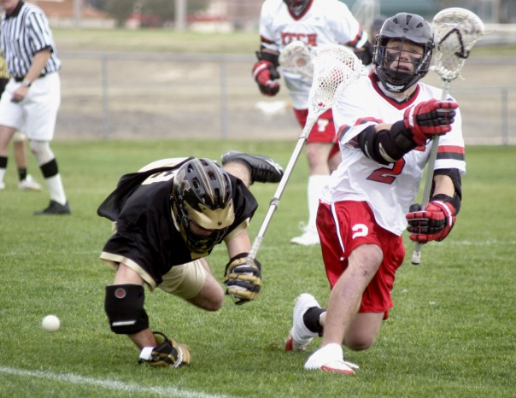
All adults who work with young people in lacrosse are in a position of trust, which has been invested in them by parents, the sport, and the young person. This relationship can be described as one in which the adult is in a position of power and influence by their position.

Positions of trust in lacrosse will include young leaders, coaches at all levels, captains, Team Manager, umpires, referees, coaches, and mentors. This list is not exhaustive

A relationship between a young person and their leader is not one of equals, it gives power to the leader and with that come responsibility, which mut be used responsibly, both on and off the pitch. This imbalance of power means understanding boundaries and respecting them is essential.

Young people trust and are dependent on leaders for their sporting development. All relationships between young people and those adults should be healthy, supportive, positive, and aimed to improve the holistic development pf all young people.

Being in a position of trust brings accountability and leaders will be seen as role models, with this comes heightened responsibility. Actions and behaviours will come under greater scrutiny, therefore language, relationships communicating must be appropriate, be aware that behaviours can be misinterpreted, whether intended or not.

In a non-sporting environment, the most obvious comparison to a position of trust is a teacher – this is a useful and relevant comparison, as boundaries in a school environment are clear. In sport these boundaries are less explicit but nonetheless as important.

Principles of good practice in a position of trust:
- Create a culture/environment that is positive, engaging, and inclusive to all.
- Always consider the impact of your actions and behaviours on young people
- Be transparent/open in your actions – it reduces the likelihood of misinterpretation.
- Know your audience, be respectful.
- Once in a position of trust, you are always in a position of trust, regardless of the environment i.e., you are still a young person’s coach when you are at a social event.
- If you are concerned your words or actions may have been misinterpreted, tell someone (Welfare Officer)

England Lacrosse has guidance on good practice in a number of areas including communication, transport, use of social media and photography all of which can be found in this document.

Below are examples of actions to avoid when in a position of trust and why:
- Giving a lift to a young person (without anyone else in the car) – could be seen as favouritism/vulnerable position for young person and leader.
- Engagement in social media – avoid 1:1 communication, do not use any language that could be seen as sexual, keep language & content appropriate.
- Do not engage in any form of sexual activity with a young person (under 18) – it is a breach of the EL Safeguarding Policy

Transition into coaching/leadership positions
It is important to remember that all coaches are in a position of trust. Newly qualified, young coaches may begin to start coaching their peers. However, it is vital that they remember they are still in a position of trust. Young people starting to coach may require greater support from their clubs to understand their role and the boundaries associated.
England Lacrosse recognises that relationships may develop between adult coaches/leaders and players. If you hold a position of trust and enter a relationship with one of your players, regardless of your age or their age. EL recommends that you withdraw from that position.
Position of trust – the legal and EL position
In March 2021, it was announced that the ‘loophole’ which previously did not protect 16- and 17-year-olds against sexual relationships with adults holding a ‘position of trust’ over them would be closed by legislation. This ‘loophole’ provided the opportunity for the power imbalance cause by positions of responsibility to be exploited. The change in legislation will specifically recognise the position of trust that sports coaches and others that have regular direct contact to children in sport.
England Lacrosse has a responsibility to protect all young people under 18 years old and takes its stance on position of trust seriously. Nobody in a position of trust must engage in sexual activity with anyone under the age of eighteen. It exploits the position of power held over the young person.
Under England Lacrosse’s Safeguarding Policy any sexual relationships with a young person are not tolerated. A breach of EL’s Safeguarding Policy would result in disciplinary action and potential intervention from other organisations, such as the police.
All those within the club have a duty to raise concerns about the behaviour of any member of the lacrosse community which may be harmful to the young people in their care, without prejudice to their own position.
The CPSU provide additional guidance on preventing abuse of positions of trust within sport.

SUPERVISION & RATIOS
Principles that underpin good practice for supervision of young people are as follows:

It is the responsibility of those commissioning, planning, or providing sessions/activities to ensure that those running the activity are suitable to do so. For example:

- They have undertaken an appropriate recruitment and selection process, this may include a DBS check (depending on the role)
- They have insurance appropriate to the activity.
- They have adopted and are implementing codes of conduct.
- They have an appropriate qualification for the activity.
- They understand their responsibility to safeguard children.
- They undertake training appropriate to the role they are doing.

Leadership, coaching, and officiating awards create opportunities for young people to develop their coaching or technical skills and sense of responsibility. However, this should not result in these young people being given full or lead responsibility for managing groups of children. Under eighteen coaches or officials should be in addition to those appropriate adults with responsibility for supervising the activity. The organisation’s duty of care and Safeguarding and Protecting Young People policy extend to all under eighteens, whether they are participants, coaches, or officials.

Whatever the recommended ratio of adults to participants is, a minimum of two adults should be present. This ensures at least basic cover in the event of something impacting on the availability of one of the adults during the activity (in the event of a participant requiring the attention of an adult during the activity following an accident for example).

In the planning of all activities, and regardless of any other assessments that may be required (for example of equipment or for Health and Safety purposes), a risk assessment should be undertaken which specifically informs decision-making about appropriate supervision levels.

Key factors to assess include:
- Age of children
- Additional supervision/support needs of some or all participants (for example due to disability)
- Competence/experience of participants for the specific activity
- Nature of activity
- Nature of venue (whether closed and exclusive, or open and accessible to members of the public).

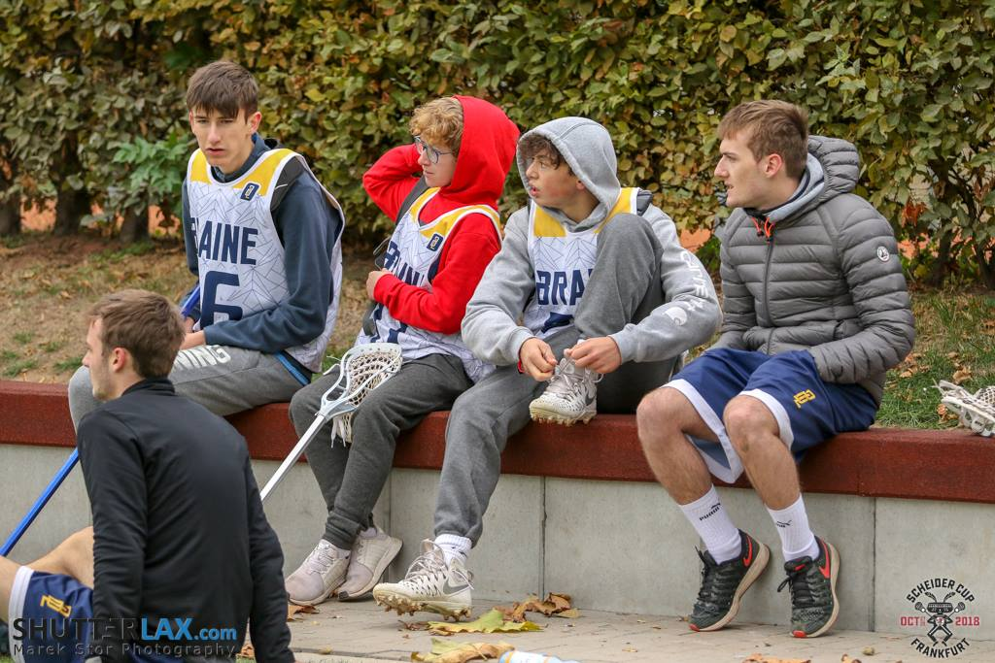

Recommended minimum supervision ratios:

Children under 8 years old:
One adult: eight children (with a minimum of two adults

Children over 8 years old:
One adult: twelve young people (with a minimum of two adults)

Junior administration e.g., signing in and out.

Administration processes such as signing young people in and out of sessions are strongly recommended as best practice for clubs with junior members.

Clubs/Associations should access their own environment, membership and resources and make their own decision on the processes they put in place to manage registration into and out of the club activity.

Clubs may decide on an age limit and most appropriate method of registration and should communicate this to all parents/guardians. This ensure that the club/association are aware of any young people who are using alternative methods to transport to get home (e.g., bus, cycling or walking). Clubs can also use this process to clearly outline their roles and responsibilities in terms of supervision i.e., at what point they become responsible for the young member.

There are many different systems that can be used to processes, whether these are online, using apps or even paper registers. This role could be completed by a number of different people, such as junior coaches parent helpers etc.

TOURS AND OVERNIGHT STAYS
Planning Competitions and Events, (including tours and overnight accommodation
When planning events, activities, competitions, or tours that involve young people there are many factors to consider and preparation is key.
It is essential to engage parents in all plans and keep them updated. It should be noted that it is the responsibly of the club/association to ensure a welfare plan is in place – It is not England Lacrosse’s role to endorse or approve welfare plans.
A detailed welfare plan should be produced including the following.
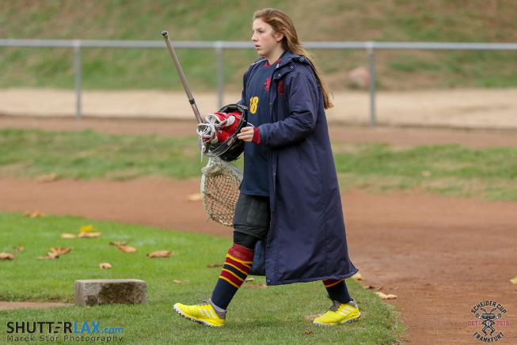

- Travel/transport
- Contact details for all adults on trip.
- Addresses of hotels/playing sites
- Medical Info
- Parents contact details.
- Code of conduct
- Alcohol guidance
- If there is a mix of genders, then appropriate changing/showering/sleeping facilities need to arrange.
- Reporting procedures
- Ratios
- Photography
- Missing player policy
- Roles and responsibilities of staff/volunteers
- Ensure appropriate checks for staff/volunteers.
- Communication
- Insurance
- If travelling abroad – passport/visas, insurance, foreign currency, medical considerations (e.g., vaccinations), mobile phones for contact
- Risk assessment for trip
Further to this, consider the following – which adults are leading the event, activity, competition, or tour?
- Do they have appropriate checks (DBS, coaching qualifications etc (?
- Who is responsible for safeguarding during the event, activity, competition, or tour?
- Completion of risk assessment of facilities, surroundings and accommodation that are being used and highlight concerns.
- Promotion of the reporting procedures for responding to and reporting concerns when first identified.
- Establish fire and emergency procedures for the duration of the event, activity, competition, or tour.
- Parental consent to include medical and photographic consent, dietary requirements, and emergency contact information.
- Detailed itinerary and information including kit.
- Ensure young people are always supervised by a minimum of two adults.
- Increased awareness of young people with additional vulnerabilities
- Arrangements for meals, arrivals, departures

Overnight Accommodation
Plans for room allocation and room sharing must also be detailed. Young people must not share a room with those over the age of eighteen, unless you are travelling with a group of young people who are 17-18 years old. E.g., peers of the same school age group. This also applies to anyone in a position of trust (e.g., coaches, umpires, mentors etc); if a 16–18-year-old is in a position of trust, they must not share a room with another young person.

For the purpose of tours and overnight accommodation, young people who are of school age but have reached their 18th birthday should be treated in the same way as those are under eighteen for the duration of the tour or overnight stay.

For more information on planning events, activities, competitions, or tours visit:

- CPSU – Safe Sports events, activities, and competition guidance
- CPSU – Safe Sports Events Management Tool
- CPSU – Away days
- CPSU – Overnight trips and travel abroad including hosting
- EL - Touring with Children Guide
- If you are organising transport as part of a tour or overnight stay, please see England Lacrosse’s Transport Guidance on the next page.

TRANSPORTATION
Volunteers, team managers, officials etc. to transport young players at any time
If, for any reason, this is the only feasible method of transport, the following guidelines must be followed:
- Drivers must ensure the safety of passengers.
- Drivers must ensure the appropriate child car seats are used.
- Drivers must ensure that their vehicle is roadworthy and that they have a valid licence and insurance cover.
- Drivers must only use vehicles with seat belts and ensure that their passengers are wearing these when in transit.
- Drivers must be aware of their legal obligations when transporting young players.
- Parents/guardians must give written permission if their child/children are being transported in another car.
- Clear information on the expected time of departure and arrivals needs to be communicated to relevant people. i.e., Parents/guardians
- Drivers should not be alone with a young person in the car at any time. If this situation arises, drivers need to ensure that the young player is in the back of the car.
- The club will ask parents/legal guardian to complete a form providing contact details, information about their child/children, i.e., medical details, etc.

Late collection
If a parents/guardians are late, the club should:

- Attempt to contact the parent/carer.
- Check the club contact number for any information regarding the young person.
- Wait with the young person at the club, with wherever possible other staff/volunteers or parents.
- Inform the club’s Welfare Officer
- Remind parents/carers of the policy relating to late collection.
- Report the situation to Local Authority Children’s Social Care Department (Social Services) or the Police if parents/carers remain uncontactable.

Staff/volunteers should avoid:

- Taking the child home or to any other location
- Asking the child to wait in a vehicle or the club with you alone.
- Sending the child home with another person without permission.

Hiring transport
When booking transport for an away fixture you will need to remember the following points:

- Passenger safety
- Competence of the driver and whether the driver holds an appropriate valid licence.
- Number of driving hours for the journey and length of the drivers’ day including non-driving hours
- Whether more than one driver is needed
- Type of journey, traffic conditions, weather, appropriate insurance cover
- Journey time, distance, and stopping points.
- Supervision requirements
- Suitability of transport if the team includes disabled players.
- Drivers will need to take breaks and be aware of emergency procedures.

Useful links - CPSU

VIDEO CONFERENCING AND LIVESTEAMING
Positive communication is essential in sport and can impact the mental wellbeing of individuals.
Since the Covid-19 pandemic, England Lacrosse are aware of an increased use of video conferencing and livestreaming platforms to connect those involved in lacrosse. Video conferencing and livestreaming can be used in many ways such as for coaches or team manager to check in with their squads or to keep connected with teammates.
If you are considering the use of video conferencing and livestreaming platforms to connect with young people, you are advised to take the following advice into account.
- Platform – There are many online platforms that can be used to livestream video calls such as Zoom, Skype, Teams etc. Ensure you use a recognised platform provider.
- Setting – Where and how is the call taking place? When making a call ensure that you are in a neutral area where nothing personal or inappropriate can be seen or heard in the background
- Consent – Ensure that parental consent is gained prior to any livestream or video conferencing calls taking place between young people and coaches/team managers.
- Parent/Guardians – Keep parents/guardians informed and updated.
- Language and Behaviour – Agree expected behaviours in line with England Lacrosse’s Code of Ethics & Behaviours (Respect) and challenge any behaviour that contravenes this.
- Duration & Timing of calls – Schedule calls at an appropriate time and ensure that the length of call is not excessive. Avoid unnecessary calls.
- Personal Details – Avoid sharing personal details such as phone numbers and email addresses.
- Reason for Calls – Video conferencing and livestreaming platforms should not be used of personal calls between coaches/team managers and young people. Ensure parents/guardians are aware of the reason for the call.
- Recording calls – Calls with young people should not be recorded, especially if the young person is not aware or has not given consent to be recoded.
- Call Settings – when setting up call with young people, ensure you check the joining settings. If you are able set default settings on the platform you are using, we strongly recommend that the following settings are used.

Mute Participants on Entry – ON
Screen Sharing – HOST ONLY
Allow Annotations – OFF
Disable Private Chat – ON
Allow Participants to use whiteboard – OFF
Remote Control – OFF
Kick User Out - ON
Where possible it is advised that more than one adult (18+ years) is present on any call, regardless of whether the call is made to a large group of young people, or on an individual basis.
Zoom-Bombing
England Lacrosse are aware that video conferencing platform Zoom has experienced an increase in hijacking of calls if the host settings are not controlled. Information on how to prevent Zoom-Bombing can be found at here
Further Information
Further guidance on the use of livestreaming or video conferencing from the Child Protection in Sport Unit (CPSU) can be found at CPSU and at England Lacrosse
If you are concerned about the welfare of a young person, you should contact your Welfare Officer or England Lacrosse’s Lead Safeguarding Consultant at safeguarding@englandlacrosse.co.uk

WHATSAPP
Good Practice for Using the App

WhatsApp is a popular instant messaging app, which lets you send messages, images, and videos to friends. You can have 1-2-1 conversations as well as group chats.
The app is being increasingly used within lacrosse as a useful communication tool. This guidance recognises good practice for using the app and highlights some risks when using it with U18’s.
DO’S AND DON’TS OF USING WHATSAPP
DO’S
- Have a coach set the group up (allowing admin rights)
- Ensure the group has at least two adults.
- Tell athletes what the app is/is not to be used for
- Inform parents of its intended use
- Get the team to agree how the app is to be used i.e., only for lacrosse orientated content.
- Keep language appropriate.
- Ensure members have a mechanism to report inappropriate content.
DON’TS
- Assume everyone is on WhatsApp.
- Use the app for private messaging.
- Use the app to replace formal feedback.
Concerns For Using WhatsApp
Individuals having access to everyone’s numbers.
In some environments this may allow individuals to contact each other in a negative way e.g., bullying in a performance environment.

Individuals not using WhatsApp.
If a member of the team does not use the app, will they miss valuable information?

This guidance should be applied to all equivalent social media/group communication apps.

YOUNG PEOPLE IN ADULT LACROSSE

England Lacrosse (EL) believe that all players should be provided with opportunities to improve their lacrosse.

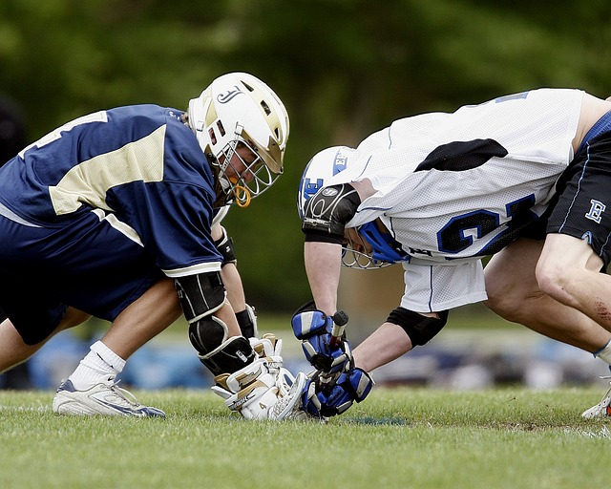

Young individuals playing club lacrosse are often introduced to senior teams and development sides, allowing them to gain experience playing with and against older players. This step up can be pivotal to their lacrosse playing career however decision can be made hastily without proper consideration for the young person involved.
It is important to remember that young athletes are not ‘mini adults’ and therefore certain considerations must be considered. This guidance intends to ensure that all lacrosse players, both adults and young people, can have a positive and enjoyable experience within lacrosse. So, what do you need to consider?
When considering the young player, there are certain areas that should be explored such as: Is it right for the player? Why is the young person playing in the senior team? What support do they require? What support does your club currently have in place for young players? What additional support do you need to consider?
There are many reasons why young people may play lacrosse on adult teams, therefore we must consider the reality of why they are involved. There may not be a junior section for players to join, therefore the only option for them to play may be in an adult team. This may be a development team encouraging young players to ‘step up’ into a more challenging environment to improve their skills. In some cases, young players might play in senior teams to make up numbers. Whatever the reason for involving young players in senior teams, it is vital that they receive a positive experience which will help them develop and grow as people and players. These young people are the future of the game and therefore they should be encouraged, supported, and developed.
It is important to maintain regular communication with young people, and their parent(s)/guardian(s) when they are playing in senior teams and to involve them in decision making. It is advised that, as a squad, you agree a set of guidelines at the start of the season that all players sign up to.

Who is a ‘young person’? `
‘Young people are defined as children that haven’t reached their 18th birthday’.
Lacrosse is one of the few sports where young people can play as part of a senior team. However, regulation states that:
As agreed by NLC and the England Lacrosse Board 2018, that junior boys may not play for a senior men’s team until they reach their 16th birthday and girls may not play for senior women’s team until they reach their 14th birthday until further notice (Juniors playing in adult league teams, 2018)
Whilst we understand that young people develop physically at various times, we can be certain that their emotional and psychological state prior to the age of fourteen if female and sixteen if male.
- Physiological and psychological maturity
- Socia media/networking
- Commitments outside of lacrosse – do they have exams, weekend, or evening jobs, what else might they do?
- Impact of peer groups
- Readiness for increased physicality of senior game
- Appropriate language and behaviour
- Peer involvement
Young people mature at different rates, both physically and emotionally. Where an individual may be ready to play in a senior team, others may not be ready to step up. This should be considered on an individual basis. Consider who is responsible for making these decisions (coach, team manager, co-ordinator, Welfare Officer etc.) and what guidance they are basing their decision on, such as policies regarding inclusion and selection criteria, and make sure these are communicated to all players and parents/guardians.
is unlikely to be mature enough to support them adequately in an adult competition. Furthermore, it seems sensible to have a concrete age for young adults to regulate participation and avoid subjective decisions.
What is the young players experience?
When young people are playing lacrosse in any capacity it is essential that they receive a positive experience, that they are encouraged to develop and that they are supported. The culture and environment within the club can have a significant impact on the experience young people have. Every player will have a different motivation and reason for playing therefore its essential to consider the following:
Age – It will be different between the age groups depending on maturity, physicality and emotionally. In some cases, it may be better for them to stay with their peers and own age group.
Experience – Linking into the above, do they have enough experience in their own age group? Are they going to have a better experience playing in a senior team?
Peers – What are their friends doing? Do they play lacrosse with them? If so moving them away from that environment may not develop them as players even if they have the talent to play in senior teams.
Readiness to transition to senior lacrosse? – Is the young person ready to transition in a senior team and will the develop? If they young person is not getting any benefit from moving out of their own age group to play in a senior team the move is not justified. For some players transition to senior teams is essential and an important part of their development. Every player will be different and transition decisions should be taken on an individual basis.
Decision to transition? – Transparency of the decision-making process around transition is helpful for all involved. Who will make that decision? What factors are considered? Clear guidance and communication of these factors are essential.
Culture – What is the attitude, language and behaviour towards young people like in you club Are you creating an environment where young people can thrive? Changing rooms, social areas (e.g., the bar) and other social activities could be challenging environments for young people if they are perceived to be unwelcoming.
Support – what support is given to young people when they are playing for a senior team? Who is responsible for their welfare? Have someone, with the right skills, appointed to offer support both on and off the field and make the transition as smooth as possible.
Consider if the senior team is in a position for a young person to join – Would it be productive and right for all involved? What else are they doing?
School – Does the young person also play for a school team? Consider if/when they are playing in school teams.
Age Groups – Are they also playing for their age group? If playing/training for/with their own age group as well as the senior team this will need to be considered
Other Sports – Is the young person taking part in any other sports at school/club outside of lacrosse? Is lacrosse their only commitment? Young people will often take part in a variety of different sports and activities, do not assume lacrosse is their only focus outside of school.
Other commitments – What else is the young person doing outside of lacrosse? E.g., school exams, music, drama, other activities. Do not assume that lacrosse is the only commitment they have.
Talented Players – for more information on EL’s Talent programme click here
It is important to be aware of the signs of overtraining when working with juniors (both in age group and senior teams). Young people are often enthusiastic and want to be involved in as many different activities as possible.
Willingness to play – As with any individual steeping into a new team, it is not uncommon that young people show a willingness to learn and be involved in all aspects of the team. In this case, it is vital that young people do not overtrain and their involvement in matches is monitored as they may continue to play within their age group as well.
Parent/Guardian expectations – consider how you manage the expectations of parents/guardians and how you plan to communicate with them (see communication guidance and parent/guardian engagement (pages 14 & 20 in this document). Young people will often be reliant on parents/guardians for support, transport, finance etc. and will want to ensure that the environment is one that is safe for their children.
Communication
How do you communicate with young people in your club/association?
It is important to follow the basic principles of communicating with young people (as found on page 14 of this document) Communication tools such as WhatsApp (page 34) have a minimum age limit and therefore must not be used as the primary method of communication for teams containing young people.
You should consider how you engage with, and manage expectations of, parents/ guardians. Regular communication is vital, do not assume that messages will be passed on to parents, inform them directly and welcome regular contact and communication as this will help develop young people within and outside of lacrosse. Young people will often be reliant on parents/ guardians for support, transport, funding etc. and will want to ensure that the environment is one that is safe for their children.
On & Off pitch environment
Consider the following:
- Who is responsible for young people when they are substituted, sent off or are injured?
- Is there sufficient support in place for young people during training and both home and away matches?
- Does the club have a transport policy for young people?
- Does the club have a changing rooms policy for when young people are present?
- Who holds contact details and medical data for young people & in what format?
- Has photography consent been gained for young people?
- Have the umpires/opposition been informed that there are young people playing?

Other considerations:
Playing positions and duration of play
Young players are often played in unfamiliar positions; for example, a promising young defender may be played as a ’midfield’ to be ‘blooded’ into an adult team. Whilst learning all positions is to be encouraged as is interchange through playing lines, denying young people the chance to develop their game within the increased pressure of an unfamiliar environment is not helpful to their development. Playing minutes - sometimes a young player will be given brief shifts of a few minutes here and there. This is not helpful to their learning and is physically poor practice.
Appropriate language and behaviour
Players/coaches/supporters – language and behaviour
Coaching language and behaviour – should be positive, structured, and inclusive. Consider how you would communicate with young people of different ages. Coaches, captains, team managers etc. Should consider how and when they communicate with young people. It may be wise to avoid singling the young person out or not communicating with them at all or making sure conversations are not 1-to-1 when speaking with young people, having someone else present may be better for both you and the young person. Would this be different for a 14- or 16-year-old?
On and off the pitch - from and towards young people
Avoid negative actions and swearing both on and off the pitch. Challenge young people if they display these behaviours. You could set standards expected of the team at the start of the season, get everyone to sign up and challenge each other if these standards are not upheld. Create a positive team experience regardless of whether young people are part of the team or not. This also relates to changing rooms, club houses and any other social setting where young people are sharing facilities with anyone over the age of eighteen. Young people can become easily intimidated and feel uncomfortable in these environments. Consider the language used and behaviour towards young people – see EL’s guidance on changing rooms for further guidance (page 11)
Reporting inappropriate language and behaviour
It is also important to ensure you report any behaviour that is racist, abusive, discriminatory, or sexual in nature to the relevant people. Ensure that all club members and associated personnel (e.g., parents) are aware of EL’s reporting policy and who they can contact if they have a concern.
Support network
Any individual who is in a ‘position of trust’ over a young person is considered to be in loco parentis for the time that young person is in their care. When the young person is on the pitch, this individual may be the coach, team manager, captain, or a nominated responsible adult. However, it is important to consider who is responsible for any young people within a senior team when they are in social settings such as: changing rooms, club house/bar area and other social activities.
Clubs/associations may also consider appointing a mentor for young people playing within senior teams who can support and encourage them, both on and off the pitch. Certain individuals working directly with young people, such as coaches, team managers team captains/nominated responsible adults will require safeguarding training and may require a valid DBS certificate. Find further information regarding safeguarding training here and DBS eligibility guidance here
What if a ‘young person’ under the age of eighteen is elected to be team captain?
Consider agreeing guidelines on what the function of communication is and challenge if anyone is using it inappropriately.
Consider appointing a mentor / named supporter to the young person so they have someone they can speak to outside of the team if they are faced with making tough decisions or feel uncomfortable.
Leadership at a young age should be encouraged, work as a team to support the young person in the best way possible but remember, they may need more support in their role.
Think about what the player is responsible for but also who is responsible for them. Again, this may be different based on age.

Social events
Lacrosse is a sociable sport, bringing together a variety of people from diverse backgrounds, including those who are U18. The sociable side of lacrosse should not be discouraged, celebrating wins, and learning from loses vastly improves team cohesion and can build lifelong friendships. If there are U18’s playing in your team, consider the following:
• Who is responsible for junior members at social events? – identify an individual within the team (captain/team manager etc.) who is responsible for the safety & welfare of junior members when at social events.
• Are their parents/guardians present?
• Do you have contact details for a parent/guardian of that U18?
• Is the U18 in a vulnerable position where they may be exposed to alcohol?
• Could you impose a curfew for U18s to prevent them being exposed to uncomfortable/inappropriate situations?
• How could you involve U18’s in social events whilst ensuring their welfare is at the forefront?
Guidance on alcohol
It is illegal for any person under the age of eighteen to buy alcohol, to have an adult buy alcohol in a licensed premise. Whilst we acknowledge that young people over the age of fifteen can consume alcohol in the presence of a parent/guardian or in a supervised environment we recommend that alcohol should not be provided to any person under the age of eighteen within lacrosse. Alternative drink options such as soft drinks/water/squash etc. should be provided.

YOUNG PLAYER MOTIVATION
It is important to consider how you can encourage and motivate young people in hockey to ensure they feel supported.
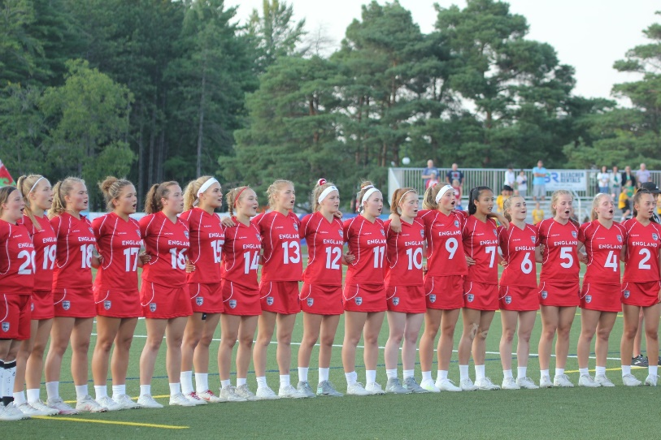
Punishments and ‘Forfeits’ will often discourage young people and can have many negative impacts, such as loss of confidence. It is essential to create an environment where young people feel support and that allows them to develop. If you are considering how to increase player motivation, consider the following:
Give players a sense of control - While guidance from a coach is important to keeping players on task and motivated, allowing players to have some choice and control over what happens in the activity is one of the best ways to keep them engaged. For example, allowing players to choose the type of activity they do or which problems to work on can give them a sense of control that may just motivate them to do more.
Define the objectives - It can be very frustrating for players to complete a task or even to behave in a session if there are not clearly defined objectives. Players want and need to know what is expected of them to stay motivated to work. At the beginning of the season (session), lay out clear objectives, rules, and expectations of players so that there is no confusion and players have goals to work towards.
Create a threat-free environment - While players do need to understand that there are consequences to their actions, far more motivating for players than threats are positive reinforcements. When coaches create a safe, supportive environment for players, affirming their belief in a player’s abilities rather than laying out the consequences of not doing things, players are much more likely to get and stay motivated to do their work. At the end of the day, players will fulfil the expectations that the adults around them communicate, so focus on can, not cannot.
Use positive competition - Competition in the coaching environment is not always a bad thing, and in some cases can motivate players to try harder and work to excel. Work to foster a friendly spirit of competition in your sessions, through group games related to the tasks and create opportunities for players to show off their skills.
Offer rewards - Everyone likes getting rewards and offering your players the chance to earn them is an excellent source of motivation. Consider the personalities and needs of your players to determine appropriate rewards for your group.
Give players responsibility - Assigning players roles and responsibilities to build a community, connection to give players a sense of motivation. Players can see roles as a privilege rather than a burden and will work hard to ensure that they, and other players, are meeting expectations. It can also be useful to allow players to take turns leading activities or helping so that each feels important and valued.
Allow players to work together - While not all players will jump at the chance to work in groups, many will find it fun to try to solve problems, and work on skills with other players. The social interaction can get them excited about things in the session and players can motivate one another to reach a goal. Coaches need to ensure that groups are balanced and fair so that some players are not doing more work than others.
Give praise when earned - There is no other form of motivation that works quite as well as encouragement. Even as adults we crave recognition and praise, and players at any age are no exception. Coaches can give players motivation by rewarding success publicly, giving praise for a job well done, and sharing exemplary work.
Be excited - One of the best ways to get your players motivated is to share your enthusiasm. When you are excited about coaching, they will be much more excited about learning. It is that simple.
Know your players - Getting to know your players is about more than just memorizing their names. Players need to know that their coach has a genuine interest in them and cares about them and their success. When players feel appreciated it creates a safe learning environment and motivates them to work harder, as they want to get praise and valuable feedback from someone they feel knows and respects them as individuals.
Help players find intrinsic motivation - It can be great to help players get motivated, but at the end of the day they need to be able to generate their own motivation. Helping players find their own personal reasons for working hard, whether because they find the sessions interesting, want to go to attend the coaching sessions is one of the most powerful gifts you can give them.
Manage player anxiety - Some players find the prospect of not doing well so anxiety-inducing that it becomes a self-fulfilling prophecy. For these players, coaches may find that they are most motivated by learning that struggling with a task is not the end of the world. Offer support no matter what the result is and ensure that players do not feel so overwhelmed by expectations that they just give up.
Make goals high but attainable - If you are not stretching and challenging your players to do more than the bare minimum, most will not seek to push themselves on their own. Players need and like to be challenged and will work to achieve high expectations so long as they believe those goals to be within their reach, so do not be afraid to push players to get more out of them.
Give feedback and offer chances to improve - Players who struggle with skill acquisition can sometimes feel frustrated and get down on themselves, draining motivation. In these situations, it is critical that coaches help players to learn exactly where they went wrong and how they can improve next time. Figuring out a method to get where players want to be can also help them to stay motivated to work hard.
Track progress - It can be hard for a player to see just how far they have come, especially with skills that are not that are difficult for them. Tracking can come in handy in the club or Performance Centre environment, not only for coaches but also for players. Coaches can use this to motivate players, allowing them to see visually just how much they are learning and improving as the year goes on.
Make things fun - Not all coaching needs to be a game or a good time, but players who see the coaching session as a place where they can have fun will be more motivated to pay attention and do the work that’s required of them than those who regard it as a chore. Adding fun activities into your session can help players who struggle to stay engaged and make the session a much more friendly place for all players.
Provide opportunities for success - Players, even the best ones, can become frustrated and demotivated when they feel like they are struggling or not getting the recognition that other players are. Make sure that all players get a chance to play to their strengths and feel included and valued.
It can make a world of difference in their motivation.
Alternative options - Rather than performing ‘forfeits’ players could be given tasks to complete such as acts of kindness, such as:
• Filling a water bottle
• Collecting balls
• Carrying a bag
• Giving praise to another player

There is also an opportunity to flip the task so that the ‘winners’ receive a bonus – this could be double point for goals scored etc. This provides a learning focus for individuals and removes the ‘punishment’ element.
Sometimes, a group simply needs to know the learning focus and can be happy to self-review it based on simple targets. No need to add false motivation with consequences, the self-fulfilling drive of sensing and gaining progress should be enough - If your Motivational Climate is clear and health.

