PARENTS BOOKLET | This booklet provides advice that will help you to give your child the best opportunity to maximise their learning and performance.

ACADEMY PARENTS
Congratulations and thank you for getting your child this far! Now that your child has been selected to be a part of the England Lacrosse Talent Pathway, it is important that you encourage them to manage their lifestyle well in order to cope with the increased demands on their time. You may need to support your child in making informed decisions and planning ahead to help them achieve success in all aspects of their life.
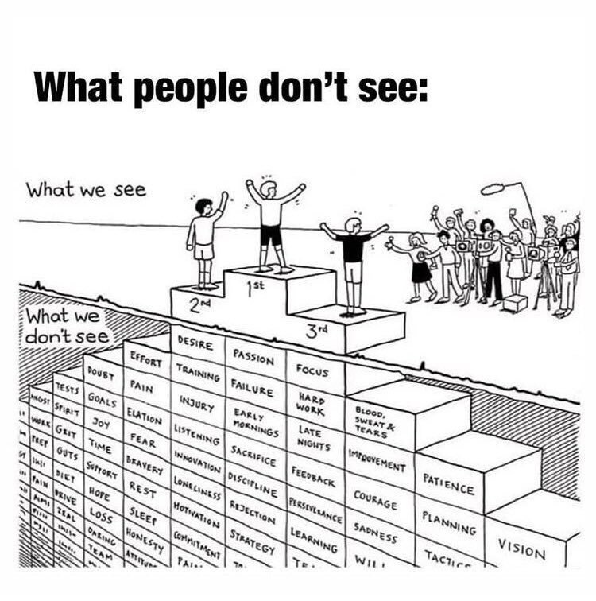
How can you prepare your child NOW to help them LATER?
While doing things for your child may seem quicker and easier now, teaching and coaching them how to do it themselves is invaluable for their future as an elite athlete.

TIME MANAGEMENT & PERSONAL ORGANISATION
Your child will need to develop the following skills to support their performance:

Encourage the use of a diary/wall planner to ensure your child is aware of training and competition, school, work and social commitments well ahead of time. If travel is required, make sure time is allowed for this too.
Encourage them to think ahead – will some periods of the year be busier than others? E.g. exam time, holidays, during competition season etc.
Start thinking about the essential things you currently do for them and encourage them to learn and adopt these for themselves for when you aren’t there!
- Managing diary/schedules.
- Getting to places on time and mode of transport
- Kit (ordering/washing).
- Planning rest/time off.
- Communicating with coaches.
MANAGING FINANCES
Encourage your child to;
- find a way to easily monitor their spending, whether this is by spending on a card or using online apps or monitoring to keep track;
- set up two bank accounts; consider one for income to go into and bills etc. to come out of and one with a spending allowance;
- regularly check their balance;
- keep a record of any of their expenditure on their sport;
- balance income and expenditure.
COMMUNICATION
Your child will need to communicate with many different groups of people (coaches, teachers, support staff, employers) to ensure that everyone is aware of their commitments.
Make sure they learn to do this themselves, using appropriate methods of communication dependent on the situation. The table below demonstrates examples of this:
Call | Email | Text
Complicated | Lots of detail | In reply to something straightforward
Controversial | Trying to find dates | Reminders
Conflict | When you need a record of the conversation | Updates to thread
Confusion |  | Friends/family
Misconstrued

SLEEP
As an extremely active athlete, your child requires more sleep than the average teenager. Sleep allows time for their body to recover and to process and consolidate the new skills that they are learning. Research shows that in order to achieve this, they should be aiming to achieve 8-10 hours of sleep a day.
With the late night and early morning training commitments your child has, you are probably thinking that this will be difficult to achieve and, on some days, it probably will be. Below, we have listed some ways in which you can help your child to sleep better and for longer, so they can best reach their full potential:
- Power naps of just 20 minutes can help boost alertness and improve motor performance. Some athletes have been allowed access to quiet rooms at school/college to have a power nap during breaks or lunch.
- Keep a pillow/eye mask/earplugs in the car- making it more comfortable will encourage naps in the car, which can be extremely beneficial.
- Ensure they have a reliable and easy to use alarm clock.
- Encourage them to do their academic work away from their bed, or better still, away from their bedroom. The associated stresses of studying do not go away when it’s time for bed and can cause disruption to sleep.
- Encourage your child not to use blue light electronic devices as they prepare to go to bed.
- Practicing relaxation techniques before bed can help relax the body and prepare the mind for sleep:
- Close your eyes and take deep slow breaths, try to make each breath even longer than the last one.
- Starting with your toes, tense the muscles as tightly as you can, then completely relax. Move up the body to your head completing the same task with each muscle group.

NUTRITION
An adequate diet is one of the most important elements for enhancing the training and performance of athletes.
WHAT FOODS SHOULD BE EATEN AROUND TRAINING AND MATCHES?
Before Training and Competition
- A carbohydrate rich meal or snack should be eaten 2-3 hours before any intense training or competition. E.g. rice, pasta, potatoes, porridge.
- A smaller snack such as a banana with peanut butter or some fruit and yoghurt to be eaten 1 hour before training or competition.
× Avoid fatty foods as they take the longest to leave the stomach and therefore may cause discomfort when exercising.
If your child struggles to eat well before exercise, or it is causing them to feel sick, then avoid solid foods and instead try a fluid based meal such as milk, yoghurt or smoothie.

During Training or Competition
Sports drinks which contain some carbohydrates are beneficial during matches to provide fuel and hydrate.
- If they prefer to eat something at half time ideal snacks would be; bananas, rice crackers, cereal bars or dried fruit;
- Ensure drink plenty of fluid. Water is a good choice, but not always the best choice for athletes. Look for drinks which contain salt and electrolytes as these help your body retain the fluid you drink.
Post Training or Competition
In order to promote a rapid recovery, it is important that refuelling takes place as soon as possible after training and competition (ideally within the first 30 mins). Look to take in both carbohydrates but and also protein (aiming for 20g of protein). The easiest is to use milk based recovery drinks or smoothies for an easy to digest initially post training/match.
Items to eat post training which can help to do this are:
- Milk, milkshakes, meal replacement drinks and recovery drinks (if your child doesn’t feel like eating solid food after exercise);
- Seed/nut based cereal bars;
- Sandwiches, bagels or rolls e.g. ham, cheese, tuna, honey, banana.
Then look to have a meal rich in 1/3 carbohydrates, 1/3 protein and 1/3 vegetables within 3-4hours.
The address below will take you to a great website which can provide some great meal ideas for athletes:
https://www.bbcgoodfood.com/recipes/collection/eat-athlete

EDUCATION
It will be crucial for your child to be able to balance their education with the demands of their lacrosse training and competition, alongside their other commitments. Encourage them to talk to their teachers about how serious their lacrosse commitment is and what it involves and utilise a personal planner to assist organising their time and commitments.
SOCIAL MEDIA
This may seem irrelevant to our younger athletes in the Talent Pathway, but we are now living in a generation of social media addicts! Anything put on the internet can sometimes stay there forever – even if you think it has been deleted.
Encourage responsible use of sites such as Twitter, Facebook and Instagram. The whole world can see everything an athlete says on Twitter and it can have incredibly damaging and long lasting results. Athletes have lost sponsors, been sent home from Olympic Games and even arrested for things they have posted online via social media sites.
Everything an athlete does or says online is representing themselves, their sport, their club, their school and England Lacrosse. Every athlete should take this seriously and prepare for the future, when their profile could be much bigger!

FINANCIAL SUPPORT FOR YOUR CHILD
We do recognise that the costs associated with your child’s attachment to the England Lacrosse Talent Pathway are high and at times this can place a strain on you as parents.
If this is the case, there are a number of different funding opportunities available to you, which you may like to investigate:

• The Lacrosse Foundation (TLF) – GRANTS Our grants programmes is open to individuals and organisations for projects that advance the vision, mission, aims and objectives of the charity;
- County Sports Partnership (CSP) – Your CSP will be able to provide you with information on any other funding that is available in your area or nationwide schemes.
If you have further queries, please contact England Lacrosse head office on 0161 974 7757.

SETBACKS AND INJURIES
Every athlete on the Talent Pathway is likely to suffer setbacks and injuries along the way – in fact it would be unusual if they didn’t! It’s unfortunately all part and parcel of performing at a higher level.
Lots of our current England Senior and National Academy athletes have had a number of unsuccessful trials along the way, as well as their share of injuries.
INJURY
Lacrosse is a sport with an intrinsic high risk of injury. The most common injuries we see are to the ankle and the knee and normally involve ligament damage.
What to do if your child sustains an injury?
If your child picks up an injury at lacrosse, it is important to get it assessed and treated. Physiotherapists can assess injuries and provide exercises and advice. Referrals can be made by NHS Physiotherapists or your GP.
If your child is unable to do any of the following, they should go to A&E to be checked out:
- Unable to weight bear on their leg;
- Swelling that happens immediately, especially in the knee;
- Inability to move the joint through the same range of movement as the other side;
- Pins and needles or numbness in the body part;
- It looks funny or pointing in the wrong direction (usually fingers).

ICE APPLICATION
Using ice is a good way to manage injuries and help with swelling and pain:
- Make sure there is no broken skin and your child can feel the body part where the ice will be applied;
- Use ice cubes in a bag and wrap it in a damp hand or tea towel;
- Apply the ice for 15 minutes with the body part elevated (resting off the floor);
- Repeat this every 2 hours for the first 3 days and then every 4 hours for the next 7 days.
Athletes should never return to playing or training without fully rehabilitating after injury, as this can lead to longer term, more serious problems. If you are in any doubt about your child’s ability to return to training, then speak to her Academy Coach or Teacher. Details of the ‘Return to Training Test’ which your child should carry out are detailed in the COACH section.
Medical/Health Insurance
Although services such as physiotherapy are available through the NHS, there are often lengthy waiting lists. Waiting for treatment of an injury will hinder your child’s recovery and delay their return to the sport.
If your child doesn’t already have a medical insurance policy, it may be worth considering taking out a policy that is suitable for them, providing them with access to private medical care as and when they need it.

